**Part 1:**

1. **Creating Functions in Python**

I understood the functions and handle basic flow in function, I have also changed the values for area of rectangle- length=6 and width=4 and then I run the code.

1. **Write a Function to Check if a Number is Prime**:

I created a function called _prime and I changed the value =9 and then I ran the code.

1. I wrote a function to count each character, it represents that the no of count a character has.

**Part 2: Creating Classes in Python**

1. I created a car class where the integers, strings and float should display same, where the make, model, year, mileage display same.

1. 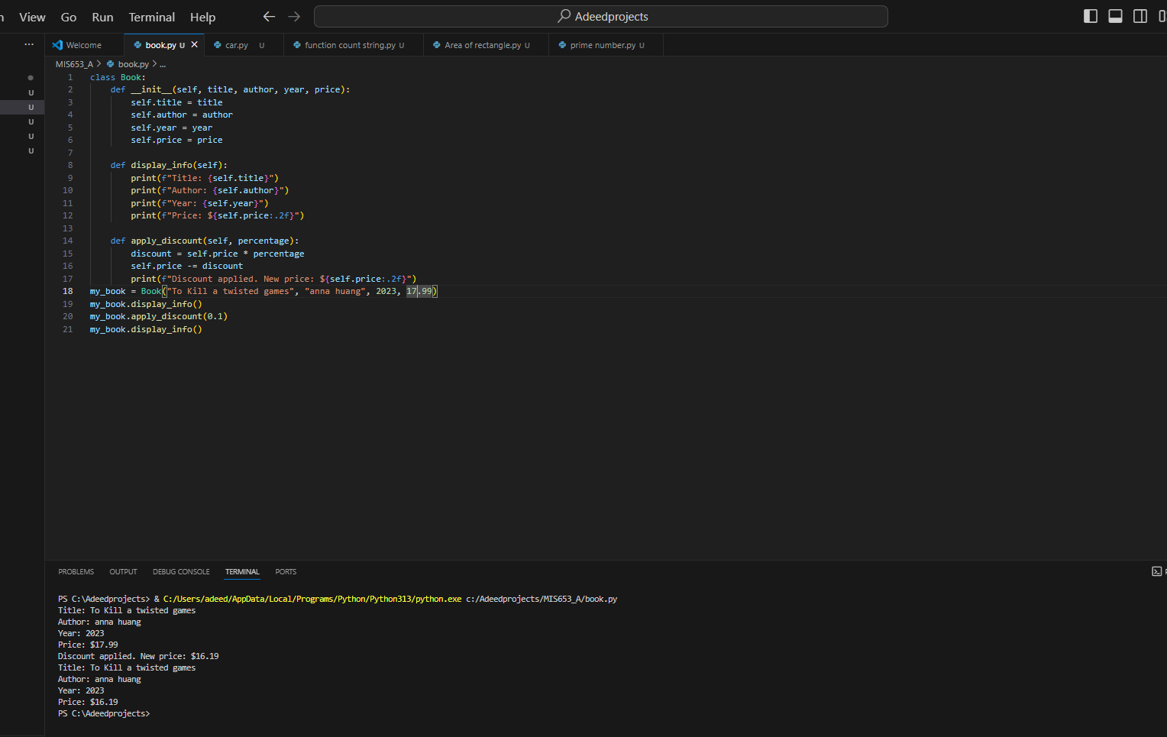I created a book class where I changed the attributes , title of the book , name of the author, year published and price and then I ran the code.